South Carolina State University / Engineering Technology Dept.
Computer Aided Drafting CET205 – Spring 2021
Midterm exam- 03/01/2021

Time: 180 minutes
Instructions to do before you start your exam:
- Write your name on all pages
- Academic dishonesty of any sort is prohibited under all circumstances. Any detected actions of dishonesty will lead to course failure.
- Show all or your work! NO WORK, NO CREDIT!
- Keep your sketch clean.
- Use ENGINEERING DRAWING Software (AutoCAD)
- GOOD LUCK

Problem # | Points Obtained
1 | /10
2 | /10
Total | /20

Tuesday - 03/01/2021

Q #1
By using AutoCAD 3D draw the figure below and you can take dimension from the Object in inches.
- Preset 3D Viewports and select Four: Right as the viewport
- Displays your objects in Realistic.
Save your drawing (Your last name.Q1.dwg)

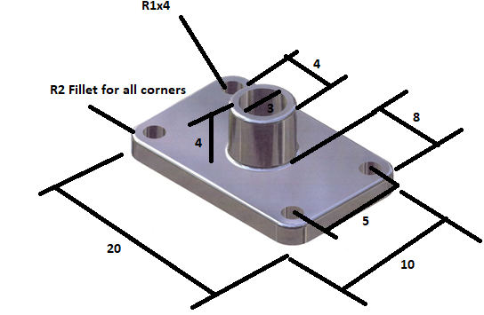

Q-2
By using AutoCAD 3D draw the figure below and you can take dimension from the Object in inches.
- Preset 3D Viewports and select Four: Right as the viewport
- Displays your objects in Realistic.
Save your drawing (Your last name.Q2.dwg)

